**PREDICTING CHANCES OF DISEASES USING MACHINE LEARNING**

**A Minor Project Report**

**Submitted in Partial fulfillment for the award of**

**Bachelor of Engineering in Computer Science & Engineering**

Submitted to

**RAJIV GANDHI PROUDYOGIKI VISHWAVIDYALAYA**

**BHOPAL (M.P)**



**MINOR PROJECT REPORT**

Submitted by

Abhishek Jain[0103CS171006]Bhola Prasad Chilhate[0103CS171046]

Krishna Yadav[0103CS171072]

Under the supervision of

Prof. Aditya Patel

Mentor CSE Dept.



**Department of Computer Science & Engineering**

**Lakshmi Narain College of Technology, Bhopal (M.P.)**

**Session 2019-20**



LAKSHMI NARAIN COLLEGE OF TECHNOLOGY, BHOPAL

**DEPARTMENT OF COMPUTER SCIENCE & ENGINEERING**

### CERTIFICATE

This is to certify that the work embodied in this project work entitled **”Predicting chances of diseases using Machine Learning”** has been satisfactorily completed by the **Abhishek Jain** (0103CS171006), **Bhola Prasad Chilhate** (0103CS171046) , **Krishna Yadav** (0103CS171072). It is a bonafide piece of work, carried out under the guidance in **Department of Computer Science & Engineering**, **Lakshmi Narain College of Technology, Bhopal** for the partial fulfillment of the **Bachelor of Engineering** during the academic year 2019-2020.

**Guided By**

## (Prof. Aditya Patel)

Mentor CSE Dept.

**Approved By**

**Prof. & Head**

# Department of Computer Science & Engineering



LAKSHMI NARAIN COLLEGE OF TECHNOLOGY, BHOPAL

**DEPARTMENT OF COMPUTER SCIENCE & ENGINEERING**

**Acknowledgement**

We express our deep sense of gratitude to Prof. Aditya Patel (Guide) department of Computer Science & Engineering L.N.C.T., Bhopal. Whose kindness valuable guidance and timely help encouraged me to complete this project.

A special thank goes to Dr. Bhupesh Gour (HOD) who helped me in completing this project work. She exchanged her interesting ideas & thoughts which made this project work successful.

We would also thank our institution and all the faculty members without whom this project work would have been a distant reality.

Abhishek Jain[0103CS171006]

Bhola Prasad Chilhate[0103CS171046]

Krishna Yadav[0103CS171072]

|  |  |  |
| --- | --- | --- |
| **S.NO.** | **TOPICS** | **PAGE NO.** |
|  | Problem Domain | 5 |
|  | Literature Survey | 6 |
|  | Major objective & scope of project. | 7 |
|  | Problem Analysis and requirement specification | 8 |
|  | Detailed Design(Modeling and ERD/DFD ) | 9 |
|  | Hardware/Software platform environment | 10 |
|  | Snapshots of Input & Output | 11-15 |
|  | Coding | 16-23 |
|  | Project limitation and Future scope | 24 |
|  | References | 25 |

**CHAPTER 1**

**PROBLEM DOMAIN**

The problem domain for this project is related to health and diagnostics in medical research and practices.

This project uses the ongoing modern technologies and tools into practice to develop a useful software or website for medical experts and general public.

We make the best use of past recorded medical data for open source repositories and machine learning technology to develop **a disease prediction system**, which uses symptoms fed by the client to predict the most likely disease related to mentioned symptoms.

This system will be helpful for general public and also for medical experts to semi-automate the diagnostic procedure of many diseases. Because it can predict possible diseases the patient may contain by analyzing the symptoms of the patients.

We will be developing a website for feeding few symptoms which further be used by the model to predict the disease. The website is expected to be interactive and simplistic.

The prediction module will be developed by the use of machine learning algorithms and will be deployed on the server end where requests can be handled and user details can be stored in a well-organized manner.

**CHAPTER 2**

**LITERATURE SURVEY**

We had gone through some research papers related to our problem domain. The most influential research was found on the following website: <https://shiring.github.io/machine_learning/2017/03/31/webinar_code>

In the above mention research the publisher took Cancer diagnostic data and built a meaningful machine learning model out of it. It shows an approach to build ml models on a specific disease and encourages us to take this further for other problem domains. This research was the main source of inspiration for our project.

We also visited some educational websites such as geeksforgeeks.com, medium.com, etc. to get general ideas to implement our problem domain by using websites as front-end.

We also decided the best method to develop our ML model (from various classification, regression algorithms).

We selected the most suitable dataset for our current problem domain after shortlisting from a few datasets with different sizes and features.

We consistently visited various educational sites for solving small sub-problems in the problem domain.

**CHAPTER 3**

**MAJOR OBJECTIVE & SCOPE OF PROJECT**

**3.1 Major objectives of project**

Following are the major objectives of our project:

* To build a meaningful machine learning model for predicting disease according to the symptoms provided.
* To develop and deploy an interactive and attractive website as our front-end of our project.
* To develop a robust back-end of the project to store user data and software, scripts and ml models.

**3.2 Scope of project**

We will build our machine learning model using python because it is very interactive and easy to code in case of developing ML models. There are various libraries available in python such as numpy, pandas, scipy, scikitlearn, etc. which are a great help in machine learning.

Also we will be using HTML, CSS, and various technologies and some python scripts and libraries such as Flask to develop website and deploy our ML model to website. We may also use MySQL as our back-end database for user data storage and other purposes.

Due to hardware limitations for building ML model, we will be using a relatively small dataset for our model which might not work much efficiently (due to small training set). Apart from hardware limitations, ML models never works fully perfect in every scenario, rather it may improve overtime.

**CHAPTER 4**

**PROBLEM ANALYSIS AND REQUIREMENT SPECIFICATION**

**4.1 Problem analysis**

Firstly, we need to develop our ML model. For that we need a reliable dataset from the internet. Then we require a development environment for developing ML model. We will be using jupyter notebook to code python scripts and will make use of libraries such as numpy, pandas, scikitlearn, etc. will add to our development. We also need a machine to code and run scripts which should be powerful enough to develop our model.

Then we need to develop a website to serve as a front-end and it would require scripting languages such as HTML and CSS. Also the n we have to develop some python scripts to deploy our ML model to the web server and require API such as Flask for connectivity of our model to the website.

We also require MySQL database deployed on our web server to store and serve user details and credentials to the website, also we require web server hardware powerful enough to handle client requests.

**4.2 Requirement Specification**

Following are the requirement specification for this project:

* Appropriate dataset for training and testing of ML model.
* Development environment such as Anaconda and python 3.
* Libraries such as numpy, pandas, scikitlearn, etc.
* Website development environment such as Notepad++ and Google Chrome.
* Scripting languages such as HTML, CSS, Python 3, etc.
* Hardware for software development and web server deployment.
* MySQL database and Python 3 as back-end storage and scripts.
* Connectivity API such as Flask.

**CHAPTER 5**

**DETAILED DESIGN ( MODELING AND ERD / DFD )**

Fig 5.1 shows the DFD for this project and Fig 5.2 shows the ERD model for the database used.

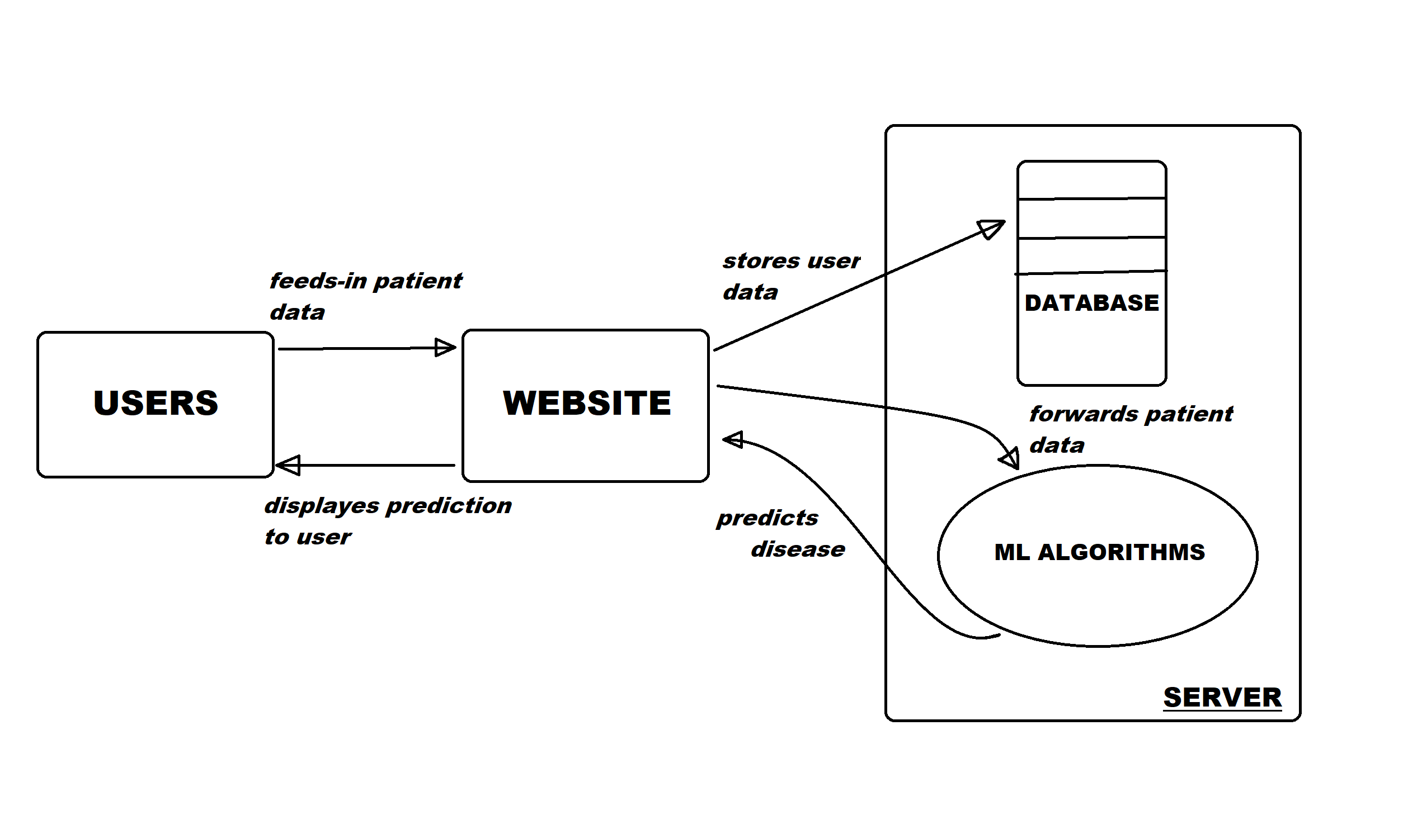

Fig 5.1 Data Flow Diagram of the project

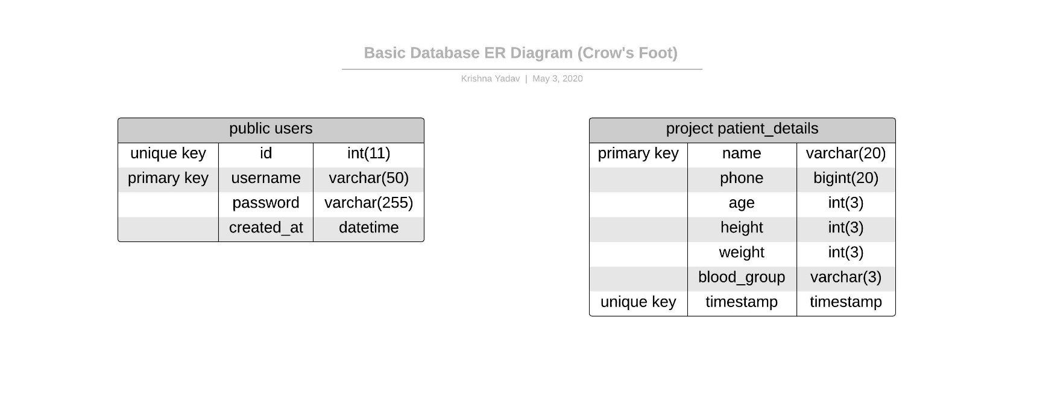

Fig 5.2 Entity-Relationship diagram of the Database

**CHAPTER 6**

**HARDWARE / SOFTWARE PLATFORM ENVIRONMENT**

Following are the hardware and software requirements for the project:

* Any PC, Laptop, Tablet or Smartphone.
* Working internet connection.
* Memory: min. 1 GB RAM (recommended).
* Operating System: Any (Windows, Linux, Android, etc.)
* Any Browser with JavaScript enabled. (Chrome, Firefox, etc.)

**CHAPTER 7**

**SNAPSHOTS OF INPUT & OUTPUT**

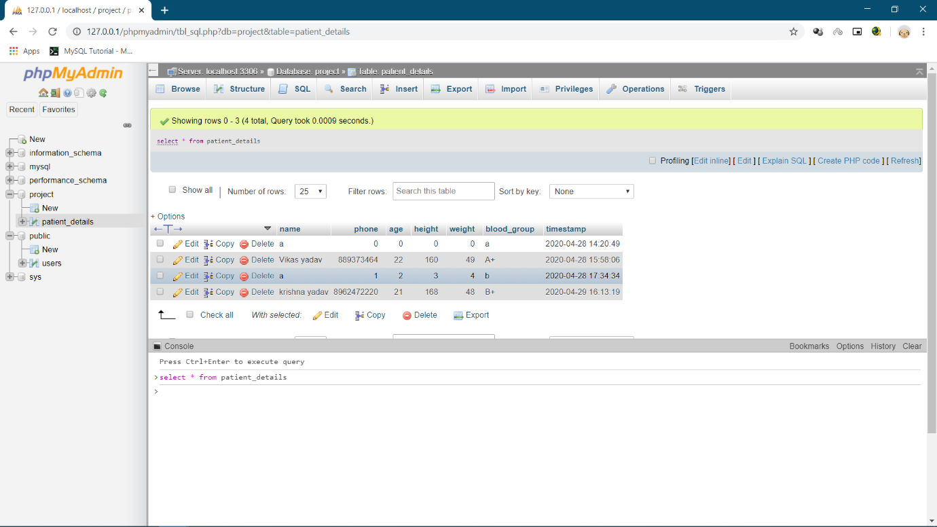

Figure 7.1 patient_details table for storing patient's details.

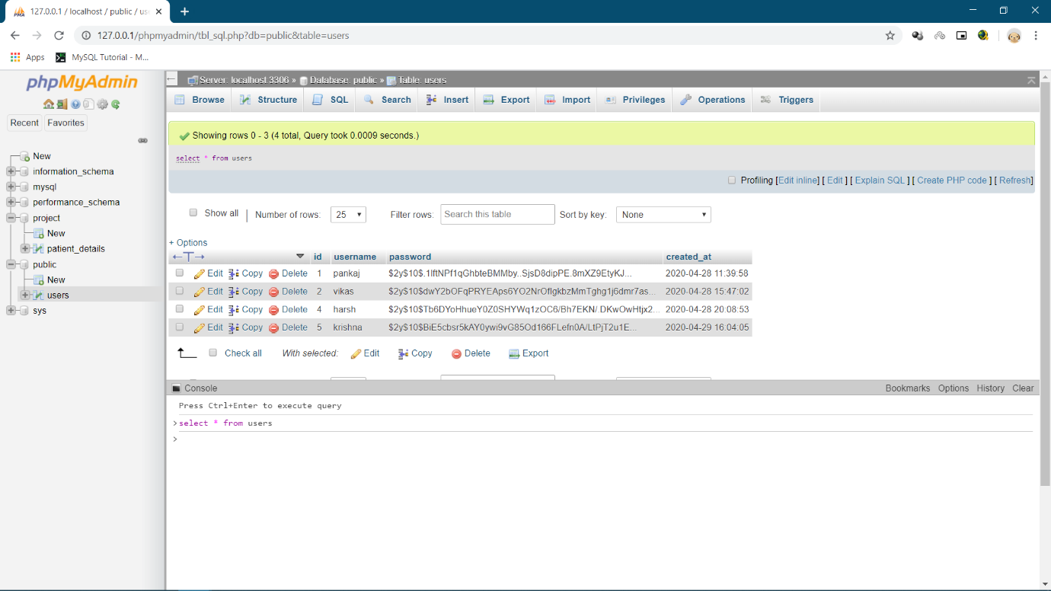

Figure 7.2 users table for storing usernames and passwords hashes.

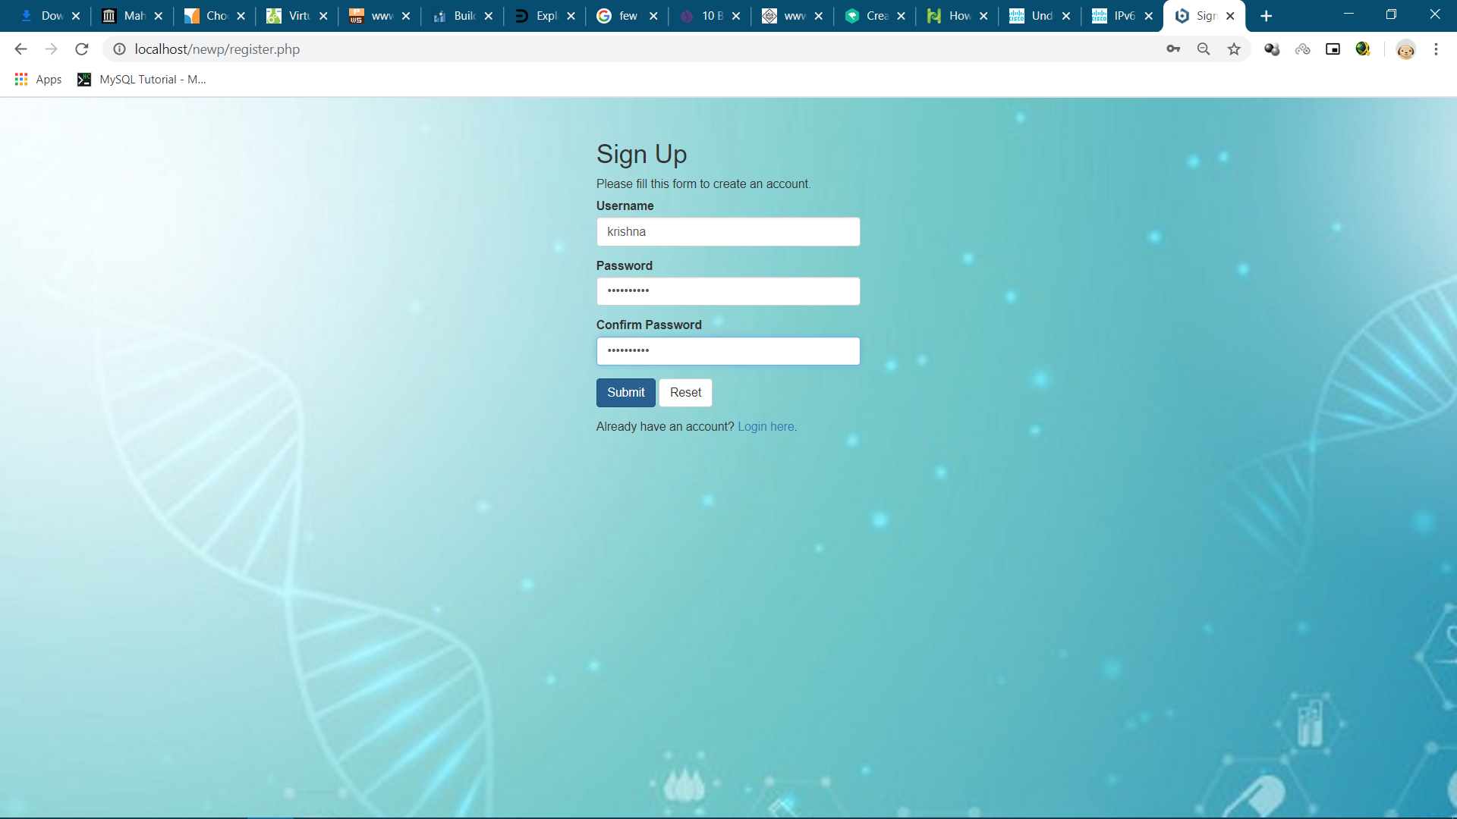

Figure 7.3 User Sign up webpage.

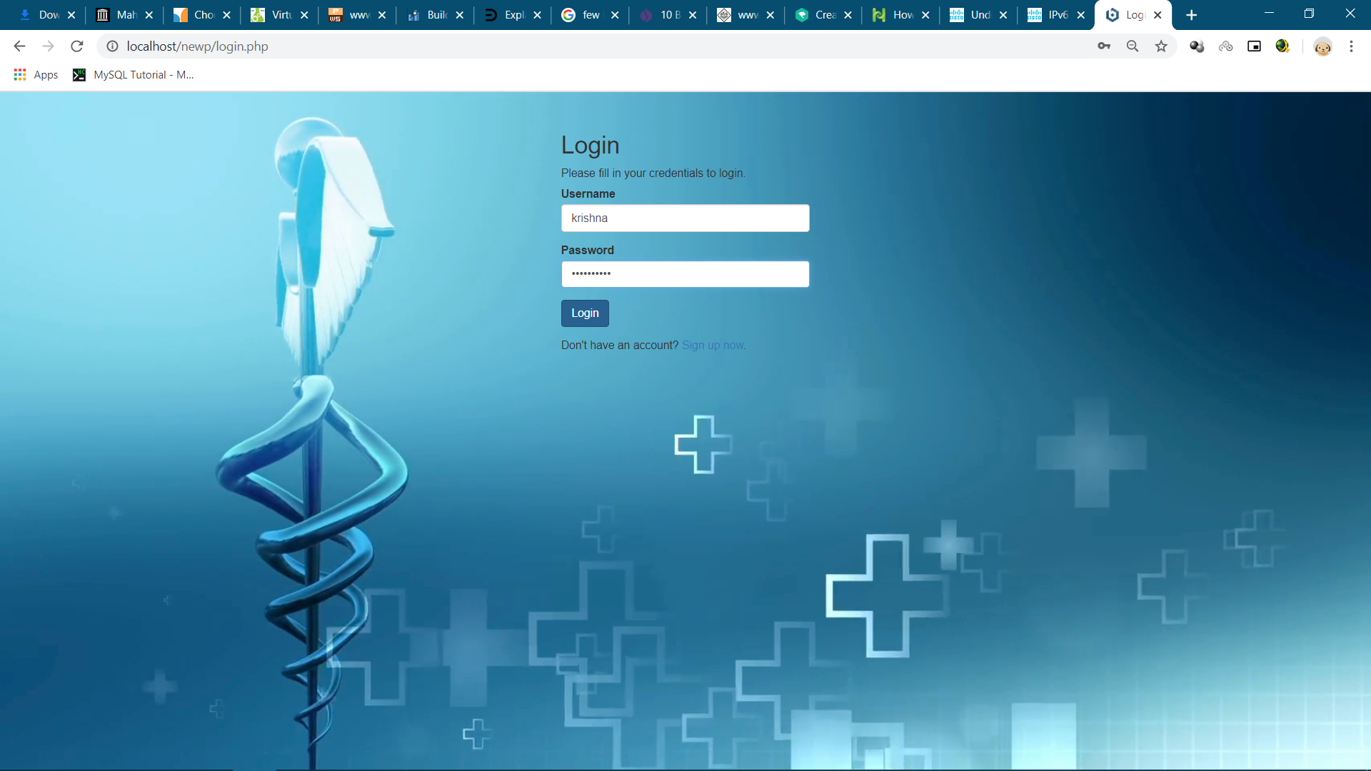

Figure 7.4 User Login Page.

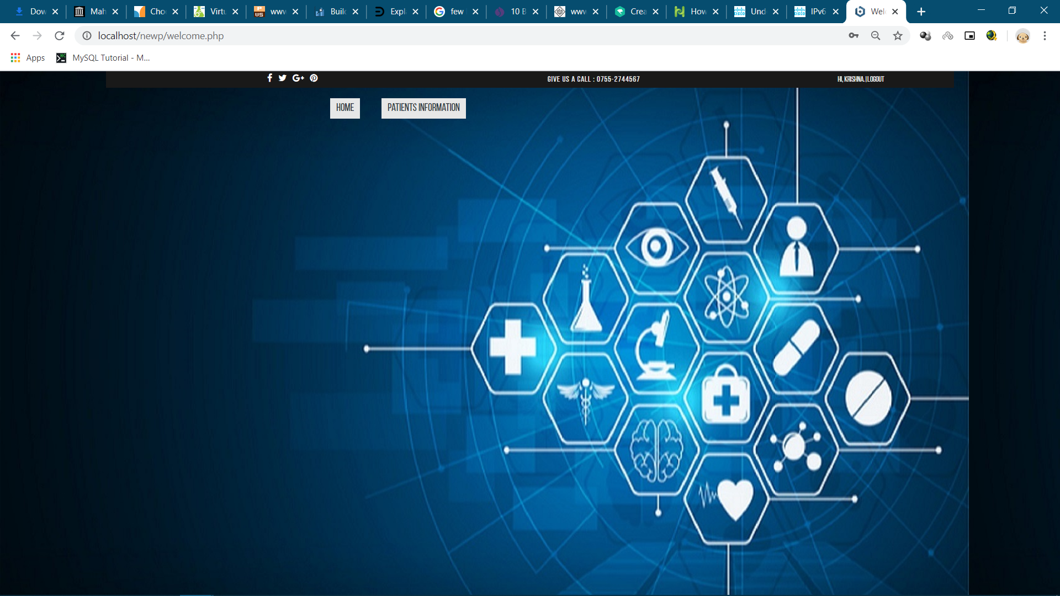

Figure 7.5 Homepage of website.

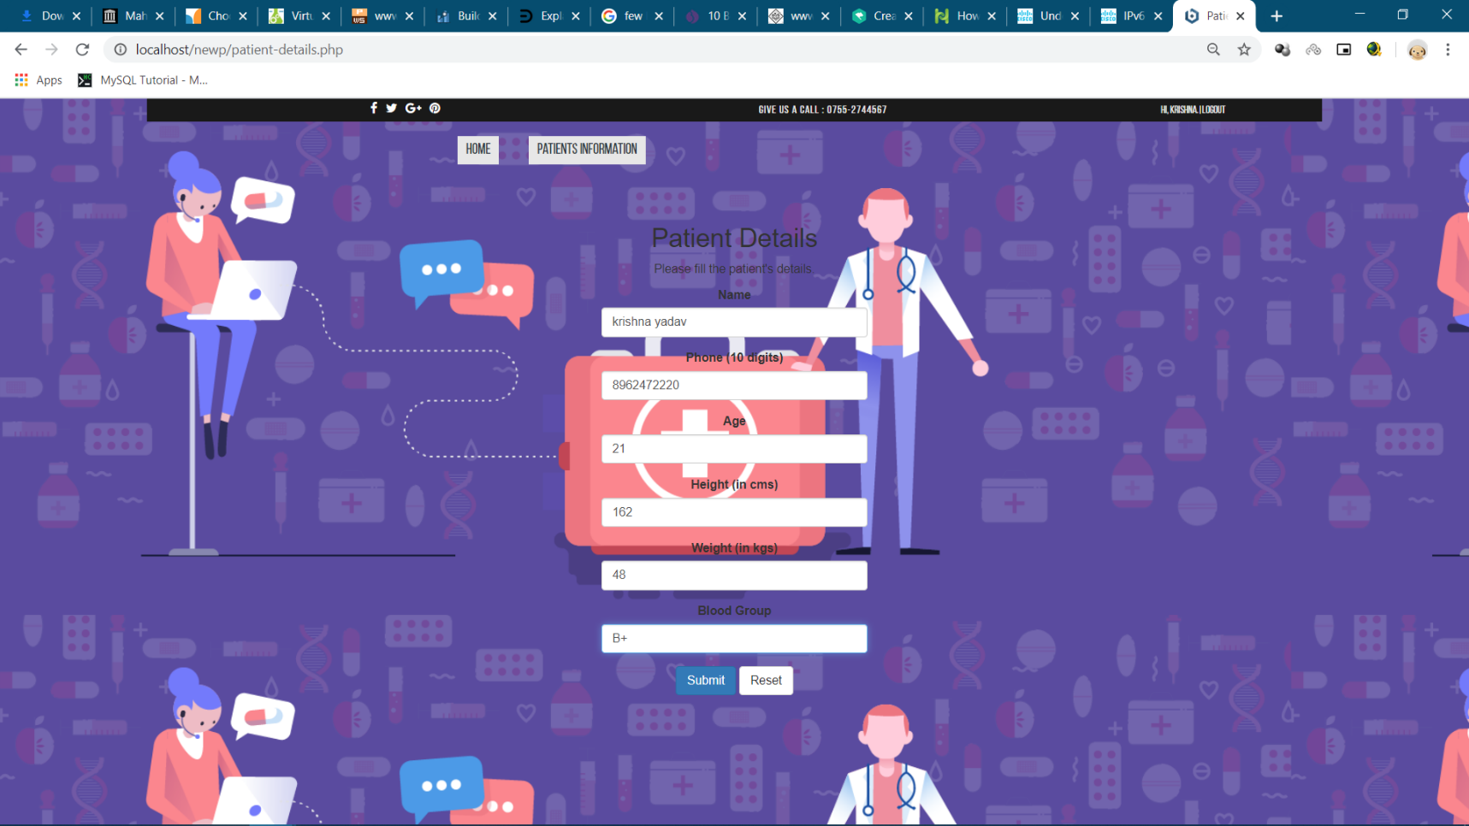

Figure 7. 6 webpage for feeding-in patient details.

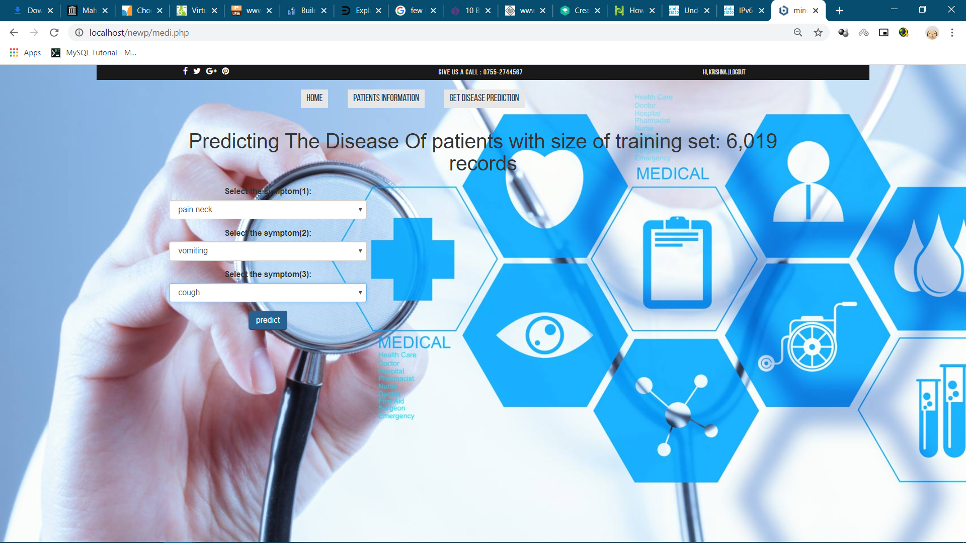

Figure 7.7 webpage for predicting disease.

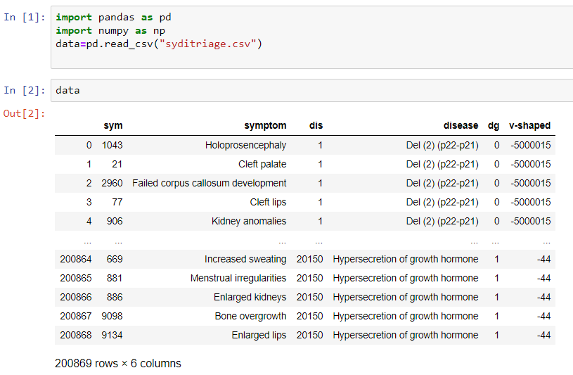

Figure 7.8 Dataset used in training machine learning model for disease prediction.

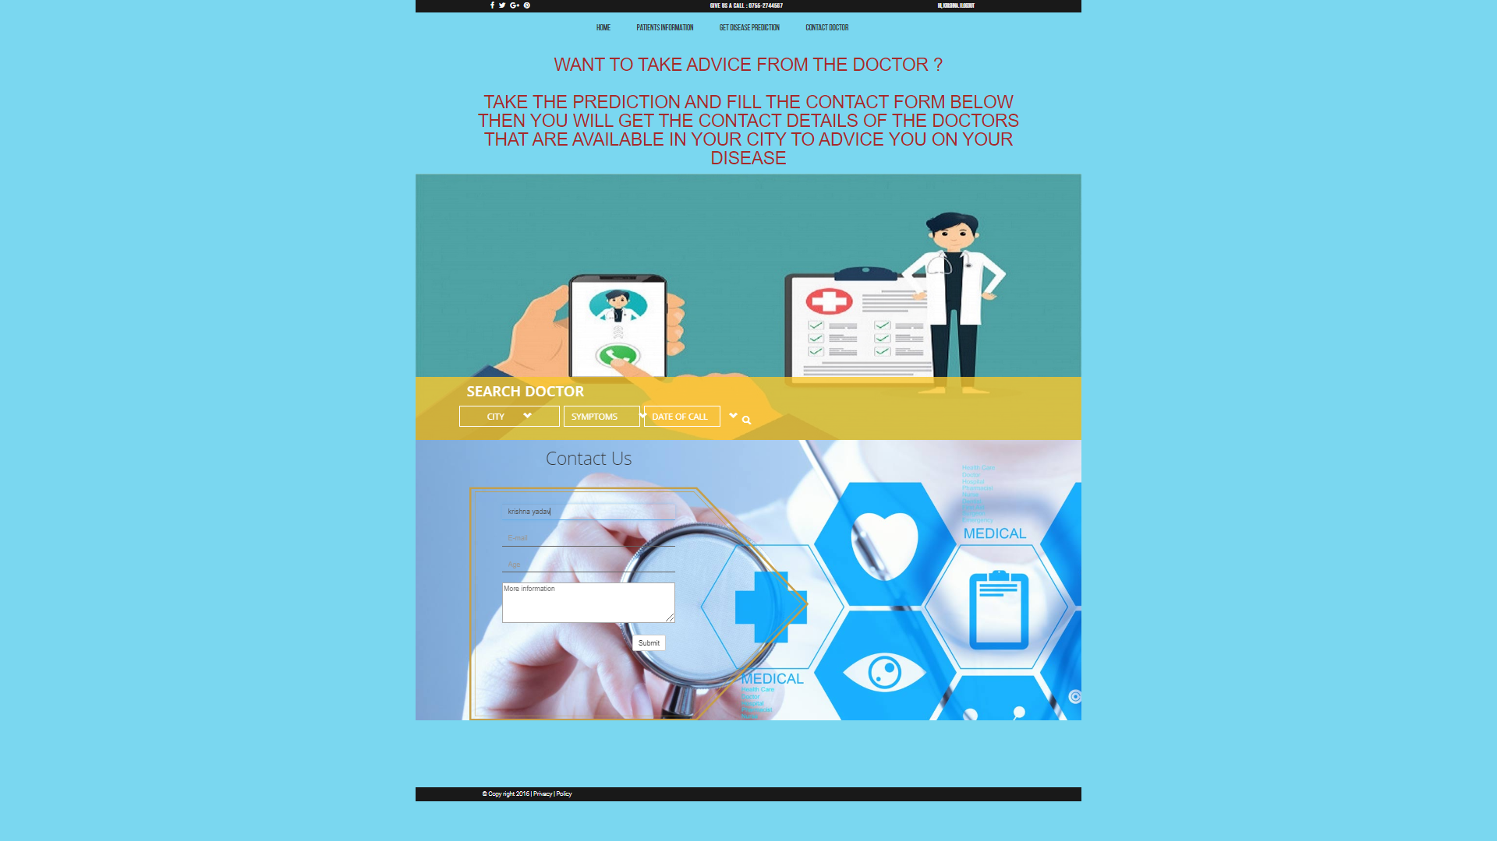

Figure 7. 2 webpage to request an appointment with the doctors.

**CHAPTER 8**

**CODING**

Code for home page of the website is given below:

**welcome.php:**

<?php session_start(); if(!isset($_SESSION["loggedin"]) || $_SESSION["loggedin"] !== true){ header("location: login.php"); exit; } ?> <!DOCTYPE html> <html lang="en"> <head> <meta charset="UTF-8"> <title>Welcome</title> <link rel="stylesheet" href="https://maxcdn.bootstrapcdn.com/bootstrap/3.3.7/css/bootstrap.css"> <style type="text/css"> body{ font: 14px sans-serif; text-align: center; } </style> <meta charset="utf-8"> <meta name="viewport" content="width=device-width, initial-scale=1"> <link rel="stylesheet" href="https://maxcdn.bootstrapcdn.com/bootstrap/3.4.0/css/bootstrap.min.css"> <script src="https://ajax.googleapis.com/ajax/libs/jquery/3.4.1/jquery.min.js"></script> <script src="https://maxcdn.bootstrapcdn.com/bootstrap/3.4.0/js/bootstrap.min.js"></script> <meta http-equiv="X-UA-Compatible" content="IE=edge,chrome=1"> <meta name="viewport" content="width=device-width, initial-scale=1.0"> <link rel="stylesheet" type="text/css" href="source/bootstrap-3.3.6-dist/css/bootstrap.css"> <link rel="stylesheet" type="text/css" href="source/font-awesome-4.5.0/css/font-awesome.css"> <link rel="stylesheet" type="text/css" href="style/slider.css"> <link rel="stylesheet" type="text/css" href="style/mystyle.css"> <link rel="stylesheet" type="text/css" href="style/contactstyle.css"> <style> body{ background-image: url("image/home.jpg"); } </style> </head> <body> <div class="allcontain"> <div class="header"> <ul class="socialicon"> <li><a href="#"><i class="fa fa-facebook"></i></a></li> <li><a href="#"><i class="fa fa-twitter"></i></a></li> <li><a href="#"><i class="fa fa-google-plus"></i></a></li> <li><a href="#"><i class="fa fa-pinterest"></i></a></li> </ul> <ul class="givusacall"> <li>Give us a call : 0755-2744567 </li> </ul> <ul class="logreg"> <li>Hi, <?php echo htmlspecialchars($_SESSION["username"]); ?>.</li> <li>|</li> <li><a href="logout.php">Logout</a> </li> </ul> </div> <!-- Navbar Up --> <nav class="topnavbar navbar-default topnav"> <div class="collapse navbar-collapse" id="upmenu" > <ul class="nav navbar-nav" id="navbarontop"> <li class="active"><a href="welcome.php">HOME</a></li> <li class="active"><a href="patient-details.php">patients information </a></li> </ul> </div> </nav> </div> </body> </html>

Code for webpage for registering patient’s details of the website is given below:

**patient-details.php:**

<?php session_start(); if(!isset($_SESSION["loggedin"]) || $_SESSION["loggedin"] !== true){ header("location: login.php"); exit; } /* Database credentials. */ define('DB_SERVER', 'localhost'); define('DB_USERNAME', 'project_admin'); define('DB_PASSWORD', 'projectpass'); define('DB_NAME', 'project'); /* Attempt to connect to MySQL database */ $link = mysqli_connect(DB_SERVER, DB_USERNAME, DB_PASSWORD, DB_NAME); if($link === false){ die("ERROR: Could not connect. " . mysqli_connect_error()); } $name = $phone = $age = $height = $weight = $blood_group =""; if($_SERVER["REQUEST_METHOD"] == "POST"){ $name = trim($_POST["name"]); $phone = trim($_POST["phone"]); $age = trim($_POST["age"]); $height = trim($_POST["height"]); $weight = trim($_POST["weight"]); $blood_group = trim($_POST["blood_group"]); $sql = "INSERT INTO `patient_details`(`name`, `phone`, `age`, `height`, `weight`, `blood_group`) VALUES (?,?,?,?,?,?)"; if($stmt = mysqli_prepare($link, $sql)){ mysqli_stmt_bind_param($stmt, "ssssss", $param_name, $param_phone, $param_age, $param_height, $param_weight, $param_blood_group); $param_name=$name; $param_phone=$phone; $param_age=$age; $param_height=$height; $param_weight=$weight; $param_blood_group=$blood_group; if(mysqli_stmt_execute($stmt)){ echo "Records inserted successfully."; header("location: medi.php"); } else{ echo "Something went wrong. Please try again later."; } mysqli_stmt_close($stmt); } mysqli_close($link); } ?> <!DOCTYPE html> <html lang="en"> <head> <meta charset="UTF-8"> <title>Patient Details</title> <link rel="stylesheet" href="https://maxcdn.bootstrapcdn.com/bootstrap/3.3.7/css/bootstrap.css"> <style type="text/css"> body{ font: 14px sans-serif; text-align: center; } .wrapper{ width: 350px; padding: 20px; } </style> <meta charset="utf-8"> <meta name="viewport" content="width=device-width, initial-scale=1"> <link rel="stylesheet" href="https://maxcdn.bootstrapcdn.com/bootstrap/3.4.0/css/bootstrap.min.css"> <script src="https://ajax.googleapis.com/ajax/libs/jquery/3.4.1/jquery.min.js"></script> <script src="https://maxcdn.bootstrapcdn.com/bootstrap/3.4.0/js/bootstrap.min.js"></script> <meta http-equiv="X-UA-Compatible" content="IE=edge,chrome=1"> <meta name="viewport" content="width=device-width, initial-scale=1.0"> <link rel="stylesheet" type="text/css" href="source/bootstrap-3.3.6-dist/css/bootstrap.css"> <link rel="stylesheet" type="text/css" href="source/font-awesome-4.5.0/css/font-awesome.css"> <link rel="stylesheet" type="text/css" href="style/slider.css"> <link rel="stylesheet" type="text/css" href="style/mystyle.css"> <link rel="stylesheet" type="text/css" href="style/contactstyle.css"> <style> body{ background-image: url("image/patientinfo.jpg"); } </style> </head> <body> <div class="allcontain"> <div class="header"> <ul class="socialicon"> <li><a href="#"><i class="fa fa-facebook"></i></a></li> <li><a href="#"><i class="fa fa-twitter"></i></a></li> <li><a href="#"><i class="fa fa-google-plus"></i></a></li> <li><a href="#"><i class="fa fa-pinterest"></i></a></li> </ul> <ul class="givusacall"> <li>Give us a call : 0755-2744567 </li> </ul> <ul class="logreg"> <li>Hi, <?php echo htmlspecialchars($_SESSION["username"]); ?>.</li> <li>|</li> <li><a href="logout.php">Logout</a> </li> </ul> </div> <!-- Navbar Up --> <nav class="topnavbar navbar-default topnav"> <div class="collapse navbar-collapse" id="upmenu" > <ul class="nav navbar-nav" id="navbarontop"> <li class="active"><a href="welcome.php">HOME</a></li> <li class="active"><a href="patient-details.php">patients information </a></li> </ul> </div> </nav> </div> <div class="container"> <div class="col-md-4"> </div> <div class="col-md-4" style="margin-top: 10px"> <div class="wrapper"> <h2>Patient Details</h2> <p>Please fill the patient's details.</p> <form action="<?php echo htmlspecialchars($_SERVER["PHP_SELF"]); ?>" method="post"> <div class="form-group "> <label>Name</label> <input type="text" name="name" class="form-control" value=""> <span class="help-block"></span> </div> <div class="form-group "> <label>Phone (10 digits)</label> <input type="text" name="phone" class="form-control" value=""> <span class="help-block"></span> </div> <div class="form-group "> <label>Age</label> <input type="text" name="age" class="form-control" value=""> <span class="help-block"></span> </div> <div class="form-group "> <label>Height (in cms)</label> <input type="text" name="height" class="form-control" value=""> <span class="help-block"></span> </div> <div class="form-group "> <label>Weight (in kgs)</label> <input type="text" name="weight" class="form-control" value=""> <span class="help-block"></span> </div> <div class="form-group "> <label>Blood Group</label> <input type="text" name="blood_group" class="form-control" value=""> <span class="help-block"></span> </div> <div class="form-group"> <input type="submit" class="btn btn-primary" value="Submit"> <input type="reset" class="btn btn-default" value="Reset"> </div> </form> </div> </div> </div> </body> </html>

Code for webpage for predicting disease of the website is given below :

**medi.php:**

<?php session_start(); if(!isset($_SESSION["loggedin"]) || $_SESSION["loggedin"] !== true){ header("location: login.php"); exit; } if($_SERVER["REQUEST_METHOD"] == "POST"){ echo "Sent"; header("location: contact.php"); } ?> <!DOCTYPE html> <html> <head> <title>minor project</title> <meta charset="utf-8"> <meta name="viewport" content="width=device-width, initial-scale=1"> <link rel="stylesheet" href="https://maxcdn.bootstrapcdn.com/bootstrap/3.4.0/css/bootstrap.min.css"> <script src="https://ajax.googleapis.com/ajax/libs/jquery/3.4.1/jquery.min.js"></script> <script src="https://maxcdn.bootstrapcdn.com/bootstrap/3.4.0/js/bootstrap.min.js"></script> <meta http-equiv="X-UA-Compatible" content="IE=edge,chrome=1"> <meta name="viewport" content="width=device-width, initial-scale=1.0"> <link rel="stylesheet" type="text/css" href="source/bootstrap-3.3.6-dist/css/bootstrap.css"> <link rel="stylesheet" type="text/css" href="source/font-awesome-4.5.0/css/font-awesome.css"> <link rel="stylesheet" type="text/css" href="style/slider.css"> <link rel="stylesheet" type="text/css" href="style/mystyle.css"> <link rel="stylesheet" type="text/css" href="style/contactstyle.css"> <style> body{ background-image: url("image/disprec.jpg"); } </style> </head> <body> <div class="allcontain"> <div class="header"> <ul class="socialicon"> <li><a href="#"><i class="fa fa-facebook"></i></a></li> <li><a href="#"><i class="fa fa-twitter"></i></a></li> <li><a href="#"><i class="fa fa-google-plus"></i></a></li> <li><a href="#"><i class="fa fa-pinterest"></i></a></li> </ul> <ul class="givusacall"> <li>Give us a call : 0755-2744567 </li> </ul> <ul class="logreg"> <li>Hi, <?php echo htmlspecialchars($_SESSION["username"]); ?>.</li> <li>|</li> <li><a href="logout.php">Logout</a> </li> </ul> </div> <!-- Navbar Up --> <nav class="topnavbar navbar-default topnav"> <div class="collapse navbar-collapse" id="upmenu" > <ul class="nav navbar-nav" id="navbarontop"> <li class="active"><a href="welcome.php">HOME</a></li> <li class="active"><a href="patient-details.php">patients information </a></li> <li class="active"><a href="medi.php">Get disease prediction</a></li> </ul> </div> </nav> </div> <div class="container"> <h1 align="center">Predicting The Disease Of patients with size of training set: 6,019 records</h1> <div class="col-md-4" style="margin-top: 10px" align="center"> <form action="<?php echo htmlspecialchars($_SERVER["PHP_SELF"]); ?>" method="post"> <div class="form-group"> <label for="carBrand">Select the symptom(1):</label> <select class="form-control" id="carBrand1" name="carBrand1"> </select> </div> <div class="form-group"> <label for="carBrand">Select the symptom(2):</label> <select class="form-control" id="carBrand2" name="carBrand2"> </select> </div> <div class="form-group"> <label for="carBrand">Select the symptom(3):</label> <select class="form-control" id="carBrand3" name="carBrand3"> </select> </div> <button type="submit" class="btn btn-primary">predict</button> </form> </div> </div> </body> </html>

**contact.php:**

<?php session_start(); if(!isset($_SESSION["loggedin"]) || $_SESSION["loggedin"] !== true){ header("location: login.php"); exit; } ?> <!doctype html> <html> <head> <meta charset="UTF-8"> <title>Contact</title> <meta http-equiv="X-UA-Compatible" content="IE=edge,chrome=1"> <meta name="viewport" content="width=device-width, initial-scale=1.0"> <link rel="stylesheet" type="text/css" href="source/bootstrap-3.3.6-dist/css/bootstrap.css"> <link rel="stylesheet" type="text/css" href="source/font-awesome-4.5.0/css/font-awesome.css"> <link rel="stylesheet" type="text/css" href="style/slider.css"> <link rel="stylesheet" type="text/css" href="style/mystyle.css"> <link rel="stylesheet" type="text/css" href="style/contactstyle.css"> <style > body{ background-color: #7ad7f0 } </style> </head> <body> <!-- Header --> <div class="allcontain"> <div class="header"> <ul class="socialicon"> <li><a href="#"><i class="fa fa-facebook"></i></a></li> <li><a href="#"><i class="fa fa-twitter"></i></a></li> <li><a href="#"><i class="fa fa-google-plus"></i></a></li> <li><a href="#"><i class="fa fa-pinterest"></i></a></li> </ul> <ul class="givusacall"> <li>Give us a call : 0755-2744567 </li> </ul> <ul class="logreg"> <li>Hi, <?php echo htmlspecialchars($_SESSION["username"]); ?>.</li> <li>|</li> <li><a href="logout.php">Logout</a> </li> </ul> </div> <!-- Navbar Up --> <nav class="topnavbar navbar-default topnav"> <div class="collapse navbar-collapse" id="upmenu" > <ul class="nav navbar-nav" id="navbarontop"> <li class="active"><a href="welcome.php">HOME</a></li> <li class="active"><a href="patient-details.php">patients information </a></li> <li class="active"><a href="medi.php">Get disease prediction</span></a></li> <li class="active"><a href="contact.php">CONTACT DOCTOR</a></li> </ul> </div> </nav> <div class="container"> <font color="brown"><h1 align="center">WANT TO TAKE ADVICE FROM THE DOCTOR ?<BR><BR> TAKE THE PREDICTION AND FILL THE CONTACT FORM BELOW THEN YOU WILL GET THE CONTACT DETAILS OF THE DOCTORS THAT ARE AVAILABLE IN YOUR CITY TO ADVICE YOU ON YOUR DISEASE</h1></font> </div> <!--_______________________________________ Carousel__________________________________ --> <div class="allcontain"> <div id="carousel-up" class="carousel slide" data-ride="carousel"> <div class="carousel-inner " role="listbox"> <div class="item active"> <img src="image/calldoc.jpg" alt="docall"> </div> </div> <nav class="navbar navbar-default midle-nav"> <div class="navbar-header"> <button type="button" class="navbar-toggle collapsed textcostume" data-toggle="collapse" data-target="#navbarmidle" aria-expanded="false"> <h1>SEARCH TEXT</h1> <span class="sr-only">Toggle navigation</span> <span class="icon-bar"></span> <span class="icon-bar"></span> <span class="icon-bar"></span> </button> </div> <div class="collapse navbar-collapse" id="navbarmidle"> <div class="searchtxt"> <h1>SEARCH DOCTOR</h1> </div> <ul class="nav navbar-nav navbarborder"> <li class="li-category"> <a class="btn dropdown-toggle btn-costume" id="dropdownMenu1" data-toggle="dropdown" aria-haspopup="true" aria-expanded="true">CITY<span class="glyphicon glyphicon-chevron-down downicon"></span></a> <ul class="dropdown-menu" id="mydd"> <li><a href="#">BHOPAL</a></li> <li><a href="#">INDORE</a></li> <li><a href="#">JABALPUR</a></li> </ul> </li> <li class="li-minyear"><a class="btn dropdown-toggle btn-costume" id="dropdownMenu2" data-toggle="dropdown" aria-haspopup="true" aria-expanded="true">SYMPTOMS <span class="glyphicon glyphicon-chevron-down downicon"></span></a> <ul class="dropdown-menu" id="mydd2"> <li><a href="#">immobile</a></li> <li><a href="#">sciatica</a></li> <li><a href="#">rest pain</a></li> <li><a href="#">dullness</a></li> <li><a href="#">pulsus paradoxus</a></li> <li><a href="#">room spinning</a></li> </ul> </li> <li class="li-maxyear"><a class="btn dropdown-toggle btn-costume" id="dropdownMenu3" data-toggle="dropdown" aria-haspopup="true" aria-expanded="true">DATE OF CALL <span class="glyphicon glyphicon-chevron-down downicon"></span></a> <ul class="dropdown-menu" id="mydd3"> <li><a href="#">TODAY</a></li> <li><a href="#">TOMORROW</a></li> <li><a href="#">DAY AFTER TOMORROW</a></li> </ul> </li> <li class="li-search"> <button class="searchbutton"><span class="glyphicon glyphicon-search "></span></button></li> </ul> </div> </nav> </div> </div> <div class="allcontain" > <div class="contact" style="background-image: url(image/disprec.jpg);"> <div class="newslettercontent"> <div class="leftside"> <img id="image_border" src="image/border.png" alt="border" > <div class="contact-form" > <h1>Contact Us</h1> <div class="form-group group-coustume"> <input type="text" class="form-control name-form" placeholder="Name"/> <input type="text" class="form-control email-form" placeholder="E-mail"/> <input type="text" class="form-control name-form" placeholder="Age"/> <textarea rows="4" cols="50" class="message-form" placeholder="More information"></textarea> <button type="submit" class="btn btn-default btn-submit">Submit</button> </div> </div> </div> <div class="google-maps"> <div id="googleMap"></div> </div> </div> </div> </div> <div class="footer"> <div class="copyright">&copy; Copy right 2016 | <a href="#">Privacy </a>| <a href="#">Policy</a></div> <script src="http://maps.googleapis.com/maps/api/js"></script> <script> var myCenter=new google.maps.LatLng(41.567197,14.681526); function initialize(){ var mapProp = {center:myCenter, zoom:16, mapTypeId:google.maps.MapTypeId.ROADMAP}; var map=new google.maps.Map(document.getElementById("googleMap"),mapProp); var marker=new google.maps.Marker({position:myCenter,}); marker.setMap(map); } </script> <script type="text/javascript" src="source/bootstrap-3.3.6-dist/js/jquery.js"></script> <script type="text/javascript" src="source/js/myscript.js"></script> <script type="text/javascript" src="source/bootstrap-3.3.6-dist/js/bootstrap.js"></script> <script> $(window).resize(function(){ var new_height = $("#image_border").height(); console.log(new_height); $("#googleMap").height(new_height); }); $(window).load(function(){ var new_height = $("#image_border").height(); console.log(new_height); $("#googleMap").height(new_height); google.maps.event.addDomListener(window, 'load', initialize()); }); </script> <script type="text/javascript" src="source/js/myscript.js"></script> <script type="text/javascript" src="source/bootstrap-3.3.6-dist/js/jquery.1.11.js"></script> </div> </div> </body> </html>

Code for webpage for user login of the website is given below:

**login.php:**

<?php session_start(); if(isset($_SESSION["loggedin"]) && $_SESSION["loggedin"] === true){ header("location: welcome.php"); exit; } require_once "config.php"; $username = $password = ""; $username_err = $password_err = ""; if($_SERVER["REQUEST_METHOD"] == "POST"){ if(empty(trim($_POST["username"]))){ $username_err = "Please enter username."; } else{ $username = trim($_POST["username"]); } if(empty(trim($_POST["password"]))){ $password_err = "Please enter your password."; } else{ $password = trim($_POST["password"]); } if(empty($username_err) && empty($password_err)){ $sql = "SELECT id, username, password FROM users WHERE username = ?"; if($stmt = mysqli_prepare($link, $sql)){ mysqli_stmt_bind_param($stmt, "s", $param_username); $param_username = $username; if(mysqli_stmt_execute($stmt)){ mysqli_stmt_store_result($stmt); if(mysqli_stmt_num_rows($stmt) == 1){ mysqli_stmt_bind_result($stmt, $id, $username, $hashed_password); if(mysqli_stmt_fetch($stmt)){ if(password_verify($password, $hashed_password)){ session_start(); $_SESSION["loggedin"] = true; $_SESSION["id"] = $id; $_SESSION["username"] = $username; header("location: welcome.php"); } else{ $password_err = "The password you entered was not valid."; } } } else{ $username_err = "No account found with that username."; } } else{ echo "Oops! Something went wrong. Please try again later."; } mysqli_stmt_close($stmt); } } mysqli_close($link); } ?> <!DOCTYPE html> <html lang="en"> <head> <meta charset="UTF-8"> <title>Login</title> <link rel="stylesheet" href="https://maxcdn.bootstrapcdn.com/bootstrap/3.3.7/css/bootstrap.css"> <style type="text/css"> body{ font: 14px sans-serif; background-image: url("image/loginimg.png"); } .wrapper{ width: 350px; padding: 20px; align-content: center;} </style> </head> <body> <div class="container"> <div class="col-md-4" style="margin-top: 10px"> <div class="wrapper"> <h2>Login</h2> <p>Please fill in your credentials to login.</p> <form action="<?php echo htmlspecialchars($_SERVER["PHP_SELF"]); ?>" method="post"> <div class="form-group <?php echo (!empty($username_err)) ? 'has-error' : ''; ?>"> <label>Username</label> <input type="text" name="username" class="form-control" value="<?php echo $username; ?>"> <span class="help-block"><?php echo $username_err; ?></span> </div> <div class="form-group <?php echo (!empty($password_err)) ? 'has-error' : ''; ?>"> <label>Password</label> <input type="password" name="password" class="form-control"> <span class="help-block"><?php echo $password_err; ?></span> </div> <div class="form-group"> <input type="submit" class="btn btn-primary" value="Login"> </div> <p>Don't have an account? <a href="register.php">Sign up now</a>.</p> </form> </div> </div> </div> </body> </html>

Code for webpage for user account registration of the website is given below:

**register.php:**

<?php require_once "config.php"; $username = $password = $confirm_password = ""; $username_err = $password_err = $confirm_password_err = ""; if($_SERVER["REQUEST_METHOD"] == "POST"){ if(empty(trim($_POST["username"]))){ $username_err = "Please enter a username."; } else{ $sql = "SELECT id FROM users WHERE username = ?"; if($stmt = mysqli_prepare($link, $sql)){ mysqli_stmt_bind_param($stmt, "s", $param_username); $param_username = trim($_POST["username"]); if(mysqli_stmt_execute($stmt)){ /* store result */ mysqli_stmt_store_result($stmt); if(mysqli_stmt_num_rows($stmt) == 1){ $username_err = "This username is already taken."; } else{ $username = trim($_POST["username"]); } } else{ echo "Oops! Something went wrong. Please try again later."; } mysqli_stmt_close($stmt); } } if(empty(trim($_POST["password"]))){ $password_err = "Please enter a password."; } elseif(strlen(trim($_POST["password"])) < 6){ $password_err = "Password must have atleast 6 characters."; } else{ $password = trim($_POST["password"]); } if(empty(trim($_POST["confirm_password"]))){ $confirm_password_err = "Please confirm password."; } else{ $confirm_password = trim($_POST["confirm_password"]); if(empty($password_err) && ($password != $confirm_password)){ $confirm_password_err = "Password did not match."; } } if(empty($username_err) && empty($password_err) && empty($confirm_password_err)){ $sql = "INSERT INTO users (username, password) VALUES (?, ?)"; if($stmt = mysqli_prepare($link, $sql)){ mysqli_stmt_bind_param($stmt, "ss", $param_username, $param_password); $param_username = $username; $param_password = password_hash($password, PASSWORD_DEFAULT); if(mysqli_stmt_execute($stmt)){ header("location: login.php"); } else{ echo "Something went wrong. Please try again later."; } mysqli_stmt_close($stmt); } } mysqli_close($link); } ?> <!DOCTYPE html> <html lang="en"> <head> <meta charset="UTF-8"> <title>Sign Up</title> <link rel="stylesheet" href="https://maxcdn.bootstrapcdn.com/bootstrap/3.3.7/css/bootstrap.css"> <style type="text/css"> body{ font: 14px sans-serif; background-image: url("image/registerimg.jpg");} .wrapper{ width: 350px; padding: 20px;} </style> </head> <body> <div class="container"> <div class="col-md-4" style="margin-top: 10px"> <div class="wrapper"> <h2>Sign Up</h2> <p>Please fill this form to create an account.</p> <form action="<?php echo htmlspecialchars($_SERVER["PHP_SELF"]); ?>" method="post"> <div class="form-group <?php echo (!empty($username_err)) ? 'has-error' : ''; ?>"> <label>Username</label> <input type="text" name="username" class="form-control" value="<?php echo $username; ?>"> <span class="help-block"><?php echo $username_err; ?></span> </div> <div class="form-group <?php echo (!empty($password_err)) ? 'has-error' : ''; ?>"> <label>Password</label> <input type="password" name="password" class="form-control" value="<?php echo $password; ?>"> <span class="help-block"><?php echo $password_err; ?></span> </div> <div class="form-group <?php echo (!empty($confirm_password_err)) ? 'has-error' : ''; ?>"> <label>Confirm Password</label> <input type="password" name="confirm_password" class="form-control" value="<?php echo $confirm_password; ?>"> <span class="help-block"><?php echo $confirm_password_err; ?></span> </div> <div class="form-group"> <input type="submit" class="btn btn-primary" value="Submit"> <input type="reset" class="btn btn-default" value="Reset"> </div> <p>Already have an account? <a href="login.php">Login here</a>.</p> </form> </div> </div> </div> </body> </html>

Code for training the machine learning model is given below:

**medi1.py:**

import sklearn

import numpy as np

import pandas as pd

import pickle

dataset = pd.read_csv('medidata.csv')

x = dataset.iloc[:,0:1].values

y = dataset.iloc[:,-1].values

from sklearn.preprocessing import LabelEncoder

lb = LabelEncoder()

x[:,0]=lb.fit_transform(x[:,0])

y[:,-1]=lb.fit_transform(y[:,-1])

from sklearn.preprocessing import Imputer

imputer = Imputer(missing_values = 'NaN',strategy='mean',axis=0)

imputer = imputer.fit(x[:,])

x[:, ] = imputer.transform(x[:,])

from sklearn.model_selection import train_test_split

x_train,x_test,y_train,y_test = train_test_split(x,y,test_size=0.1,random_state = 0)

#print(x_test[1])

#fitting simple linear regression to the training set

from sklearn.linear_model import LinearRegression

regressor = LinearRegression()

regressor.fit(x_train,y_train)

pickle.dump(regressor,open('model.pkl','wb'))

model = pickle.load(open('model.pkl','rb'))

#predict the test set results

y_pred = regressor.predict([[int(Target), int(Weight)]])

from sklearn.metrics import accuracy_score

print(accuracy_score(y_test ,y_pred))

Code for deploying machine learning model on the website is given below:

**app.py:**

import numpy as np

from flask import Flask, request, jsonify, render_template

import pickle

app = Flask(__name__)

model = pickle.load(open('model.pkl', 'rb'))

@app.route('/')

def home():

return render_template('medi1.html')

@app.route('/predict',methods=['POST'])

def predict():

'''

For rendering results on HTML GUI

'''

int_features = [int(x) for x in request.form.values()]

final_features = [np.array(int_features)]

prediction = model.predict(final_features)

output = round(prediction[0], 2)

return render_template('result.html', prediction_text='The predicted value of the disease should be {}'.format(output))

if __name__ == "_main_":

app.run(debug=True)

**CHAPTER 9**

**PROJECT LIMITATION AND FUTURE SCOPE**

**9.1 Project limitations**

This project might have following limitations:

* This project only provide solution through website and it does not provide any application for the user. So it is limited to websites only.
* Internet connection is must for serving the purpose of the problem. So, the project doesn’t work when offline.
* The dataset used in developing the model is relatively small which might affect the accuracy of the prediction of our project.
* Due to hardware limitations of the developing environment, the ML model is less reliable and less accurate.
* In practice, ML model are never said to be always accurate in predicting as compared to actual human being’s prediction.

**9.2 Future Scope**

Following key points can add up to the future scope of the project:

* We can improve our ML model’s accuracy by increasing development environment capabilities and using a bigger and more accurate dataset.
* We can embed our ML model into the website so that it can also work even in offline mode.
* We can also develop applications for various platforms such as iOS, Android, Windows, etc. to be more reliable.
* We can also upgrade the website into an Online Medical Consultation System.

**CHAPTER 10**

**REFERENCES**

* <https://elitedatascience.com/>
* <https://shiring.github.io/machine_learning/2017/03/31/webinar_code>
* <http://archive.ics.uci.edu/ml/datasets/Breast+Cancer+Wisconsin+%28Diagnostic%29>
* <https://www.google.com/>
* Websites like [www.javatpoint.com](http://www.javatpoint.com), [www.geeksforgeeks.com](http://www.geeksforgeeks.com), etc.